Use Case 1: Convert temperature from Fahrenheit to Celsius

Step 1. User opens the app.

Step 2. The app shows the UI.

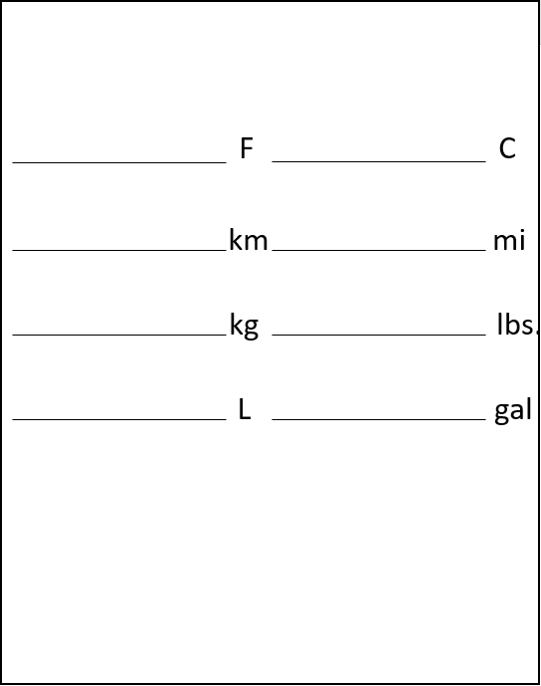

Step 3. User inputs a temperature value in Fahrenheit.

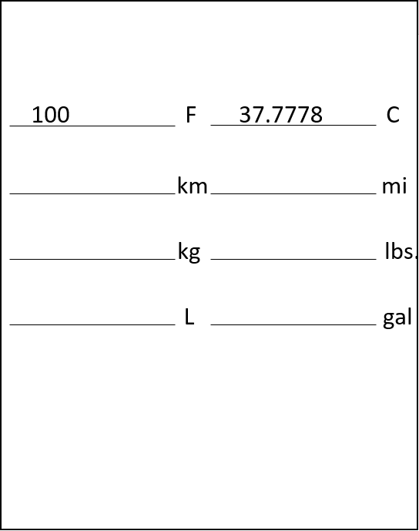

Step 4. The app automatically converts the temperature into Celsius and show the result.



Use Case 2: Convert distance from kilometers to miles

Step 1. User opens the app.

Step 2. The app shows the UI.



Step 3. User input a distance value in kilometers.

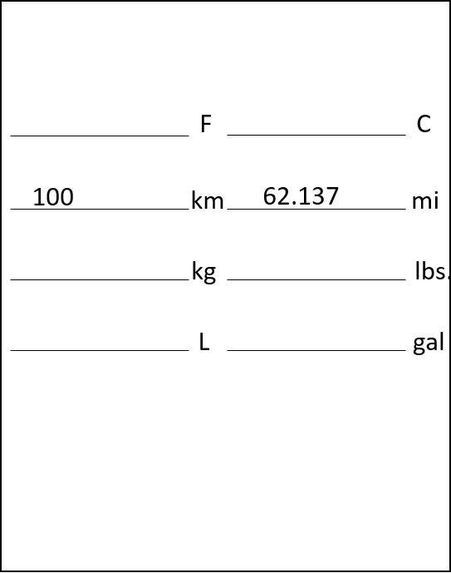

Step 4. The app automatically converts the value into miles and show the result.



Use Case 3: Convert weight from kilograms to lbs.

Step 1. User opens the app.

Step 2. The app shows the UI.



Step 3. User input a weight value in kilograms.

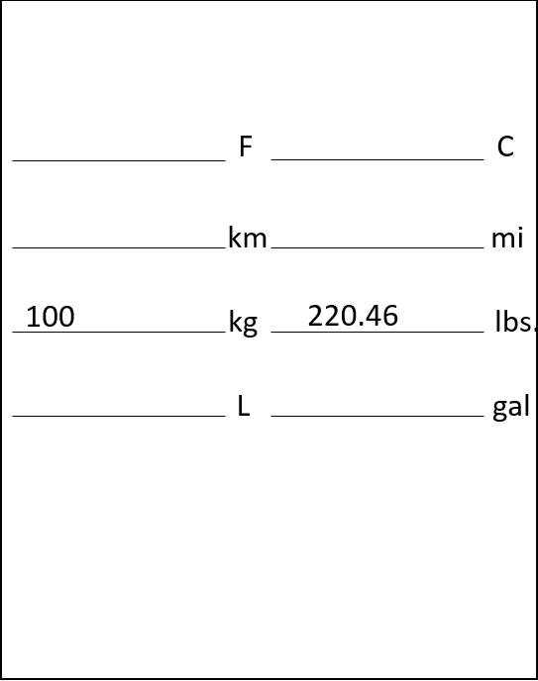

Step 4. The app automatically converts the value into lbs. and show the result.



Use Case 4: Convert volume from liter to gallon.

Step 1. User opens the app.

Step 2. The app shows the UI.



Step 3. User input a volume value in liter.

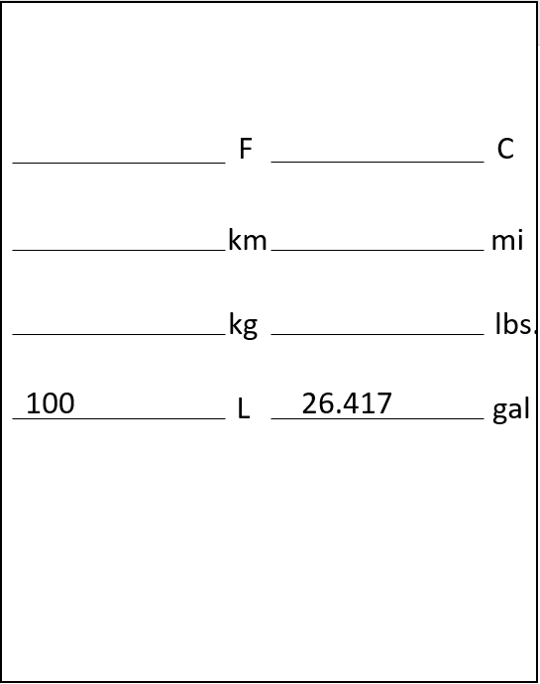

Step 4. The app automatically converts the value into gallon and show the result.

